React.js Assignment
To-Do App
Building task management with useState and useRef
Subject | React.js | Difficulty | Intermediate
Topics | useState, useRef | Time | 2–3 Hours
Type | Individual | Submission | GitHub Link + Screenshot

Objective
Build a fully functional To-Do app using only React hooks — no external state libraries.

Sample UI screen
The screen below is your design target. You do not have to match the colours exactly, but all labelled features must be present and working.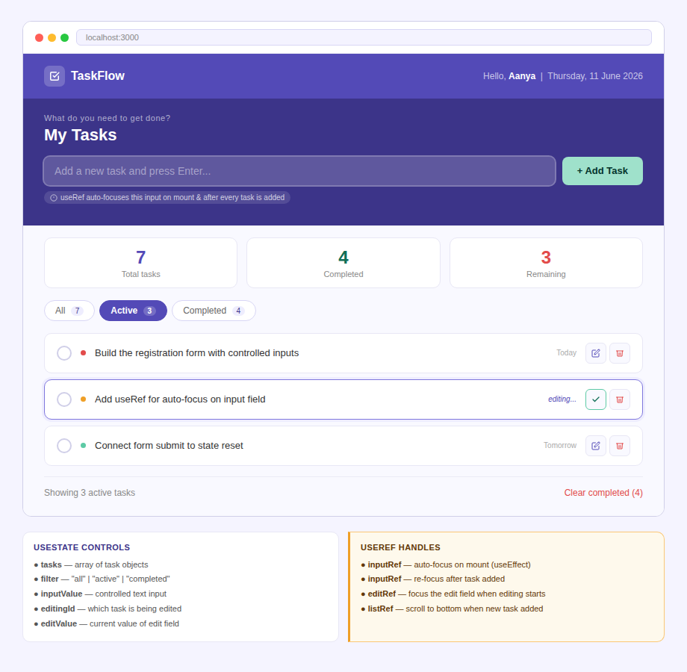

Tasks

Task 1 — Add a task
Create a controlled text input bound to a state variable (e.g. inputValue). When the user presses Enter or clicks Add Task:
- Append a new task object to the tasks array in state
- Each task object must have: { id, text, done: false }
- Clear the input field
- Re-focus the input using useRef so the user can type immediately

Task 2 — Toggle and delete
- Clicking a task's checkbox should toggle its done property between true and false
- Use .map() to return the updated array — never mutate state directly
- Clicking the delete button removes the task using .filter()
- Completed tasks must show a strikethrough style

Task 3 — Filter view
- Store the active filter in state: "all" | "active" | "completed"
- Derive the visible list using .filter() — do NOT store a separate filtered array in state
- Show a count badge on each filter button (e.g. Active 3)
- Display summary stats: total tasks, completed, remaining

Task 4 — Inline editing (useRef)
- Double-clicking a task text switches it into an edit input
- Store the editing task id in state (editingId) and the current edit value (editValue)
- Use a ref to auto-focus the edit input the moment it appears (inside a useEffect)
- Pressing Enter or clicking the save button confirms the edit; pressing Escape cancels it

The core useRef rule
You must use useRef for auto-focus behaviours. Ask yourself: if I used useState here instead, would the component re-render unnecessarily? If yes, useRef is the right choice.

Recommended state structure

useState variables  - tasks — array of { id, text, done }  - inputValue — string (controlled input)  - filter — 'all' | 'active' | 'completed'  - editingId — number or null  - editValue — string (edit input value) | useRef variables  - inputRef — attached to the add-task input  - editRef — attached to the inline edit input  - listRef — attached to the task list container  - (optional) prevLengthRef — stores previous task count

Deliverables
- Working React component (single file is fine)
- No external state libraries — only useState, useRef
- At least two useRef usages that cannot be replaced with useState
- Inline edit working with auto-focus via useRef
- GitHub repository with a short README
- One screenshot of the app running in the browser

Bonus challenges (optional)
- Persist tasks to localStorage — reload the page and tasks should still be there
- Add a priority level (High / Medium / Low) shown as a coloured dot
- Drag-and-drop reorder using the HTML5 Drag API
- Add a due date field and sort tasks by nearest due date

Assignment prepared for React.js batch | Contact your instructor for any queries

